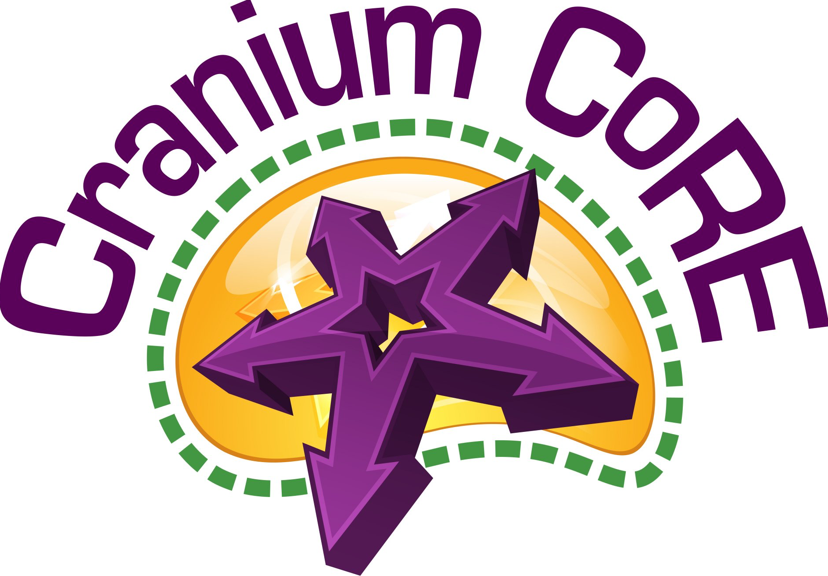
Read, Write, Speak, Listen!

Making ELA Standards Engagingly Fun and Relevantly Rigorous for Future Ready Schools, Teachers, Librarians, and Students

Cranium CoRE Academic Gaming Supports Florida Language Arts K12 Standards

Reading

Cluster 1: Key Ideas and Details

Standard 1: Read closely to determine what the text says explicitly and make logical inferences from it; cite specific textual evidence when writing or speaking to support conclusions drawn for the text.
Support: The Cranium CoRE gaming process includes extra points given to any team for giving text based evidence to successfully defend any of the questions in the game using the author’s words. The questions are typically textually complex, higher order thinking type ( H.O.T.) questions.

Standard 2: Determine central ideas or themes of a text and analyze their development; summarize the key supporting details and ideas.
Support: There are H.O.T. Cranium CoRE question types that require the teams to
- Identify Details to Support a Conclusion (What details in the text support…?)
- Draw Conclusions about Information from the Text (Which of these can the reader most conclude based on….?)
- Find the main idea (Which of these is the main idea in……?)
- Analyze a portion of the text (What is the central problem in…?)

Standard 3: Analyze how and why individuals, events and ideas develop and interact over the course of a text.
Support: There are H.O.T. Cranium CoRE question types that require the teams to
- Describe cause and effect (How did? Why did? What caused?)
- Analyze a portion of the text (What is the effect? How does…change?)

Reading

Cluster 2: Craft and Structure

Standard 4: Interpret words and phrases as they are used in a text, including determining technical, connotative, and figurative meaning, and analyze how specific word choices shape meaning or tone.
Support: There are H.O.T. Cranium CoRE question types that require the teams to
- Make conclusions about meanings of words or phrases in context (What does …mean? What does the author mean…? What does the author imply….?)
- Analyze the use of persuasive language (What tone does the author create…..? What does the author mean or imply…..?)

Standard 5: Analyze the structure of texts, including how specific sentences, paragraphs, and larger portions of text (i.e. chapters, scenes, etc.) relate to each other and the whole.
Support: There are H.O.T. Cranium CoRE question types that require the teams to
- Analyze a portion of the text (Compare/contrast - How does ….most compare with….?)
- Use a quotation to analyze the purpose of a passage (Literary Device type question - What literary device is the author using here? or What does this….mean?)
Standard 6: Assess how point of view or purpose shapes the content and style of a text.
Support: There are H.O.T. Cranium CoRE question types that require the teams to
- Explain the author’s purpose (What was the author’s main purpose for…? What tone did the author create ….?)

Reading

Cluster 3: Integration of Knowledge and Ideas

Standard 7: Integrate and evaluate content presented in diverse media and formats, including visually and quantitatively, as well as in words.
Support: There are H.O.T. Cranium CoRE question types that require the teams to
- Draw conclusions about information from the text (Based on the chart in this chapter, which of these could the reader most conclude? Based on the map in Document B, which of these statements is the most accurate?)

Standard 8: Delineate and evaluate the argument and specific claims in a text, including the validity of the reasoning as well as the relevance and sufficiency of the evidence.
Support: There are H.O.T. Cranium CoRE question types that require the teams to
- Analyze the validity of information within the text (Which of these statements is the most valid based on..?)

Standard 9: Analyze how two or more texts address similar themes or topics in order to build knowledge or to compare the approaches the author/s take/s.
Support: There are H.O.T. Cranium CoRE question types that require the teams to
- Analyze a portion of text Compare/contrast (How does ….. most compare with….. How is …. different from…..? What is the effect of comparing …. to ……..?)

Writing

Cluster 1: Text Types and Purposes

Standard 1: Write arguments to support claims in an analysis of substantive topics, using valid reasoning and relevant and sufficient reasoning.
Support: The composition of textually complex, higher level thinking questions with one answer that is most correct and potentially three answers that are close is an extremely rigorous task. Whether it is for informational text or fictional literature, it is a great exercise for writing and thinking. The goal would be to first expose students in an engaging way to these H.O.T. questions in the Cranium CoRE games. The next step would be to then scaffold them to become game making question writers using the same types of H.O.T. questions.

Writing

Cluster 2: Production and Distribution of Writing

Standard 4: Produce clear and coherent writing in which the development, organization, and style are appropriate to task, purpose and audience.
Support: The result of thinking through and composing the multiple types of higher level thinking, textually complex questions, regardless of the topic, grade level, and whether or not the text is informational is extremely demanding yet very fulfilling.

Standard 5: Develop and strengthen writing as needed by planning, revising, editing, rewriting, or trying a new approach.
Support: Whether it is term paper, a letter, a thesis, a journal or higher order thinking questions for a game show, the writing process listed in this standard is the very much the same for all types of writing. For our website, here are the steps: 1) Compose - Write the game questions and answers, 2) Publish - electronically publish the games with the questions/answers on our website, 3) Play the games to evaluate them, 4) Edit, 5) Rewrite, republish as needed.

Standard 6: Use technology, including the Internet to produce and publish writing and to interact and collaborate with others.
Support: The gaming website, www.craniumcore.com, was designed for electronic publication of games as well as collaborative interaction over distances with other students/teams/schools.

Writing

Cluster 3: Research to Build and Present Knowledge

Standard 7: Conduct short as well as more sustained research projects based on focused questions, demonstrating understanding of the subject under investigation.

Support: This standard presents a great opportunity to really engage students by challenging them to compose textually complex, higher order thinking game questions with answers, especially for informational text. Writing these type questions well is as rigorous a task as there is in language arts.

Standard 9: Draw evidence from literary or informational texts to support analysis, reflection, and research.

Support: The entire process of writing textually complex H.O.T. questions with answers is evidence-based throughout. This process applies equally well in a rigorous way to literary or informational texts, uses technology in a relevant way and is collaborative in its core.

Writing

Cluster 4: Range of Writing

Standard 10: Write routinely over extended time frames (time for research reflection, revision) and shorter time frames (a single sitting or a day or two) for a range of tasks, purposes, and audiences.

Support: One improves at writing by writing. This team oriented, academic game question writing is just one of many very authentic, purposeful ways to practice this thinking skill of writing. It is also highly engaging and fulfilling to witness a group of students playing a game you helped create and watching the teams having a great thematic discussion as a result.

Speaking & Listening

Cluster 1: Comprehension and Collaboration

Standard 1: Prepare for and participate effectively in a range of conversations and collaborations with diverse partners, building on other’s ideas and expressing their own clearly and persuasively.

Support: Cranium CoRE nails this one spot on. The purpose for the team gaming process is to foster collaborative discussion among teammates to find the text-based evidence using the author’s words to answer textually complex, higher order thinking questions. Beyond that, it is to help initiate thematic discussions, even arguments, across teams about a variety of topics, all based on the literary or informational text being used.

Standard 2: Integrate and evaluate information presented in diverse media and formats, including visually, quantitatively, and orally.

Support: Cranium CoRE was designed to be used with any medium desired (print, maps, paintings, movies, etc.). The key is to justify and defend positions taken using evidence at hand.

Standard 3: Evaluate a speaker’s point of view, reasoning, and use of evidence and rhetoric.

Support: The Cranium CoRE gaming process is similar to a team oriented debate. Any team member can practice the skill of elocution and logic by using text based evidence, most often the author’s words, the defend the answers to challenging questions. Or, what is even more rigorous, work as teammates to develop their own questions together for others to wrestle with in order to find their answers and evidence.

Speaking & Listening

Cluster 2: Presentation of Knowledge and Ideas

Standard 4: Present information, findings, and supporting evidence such that listeners can follow the line of reasoning and the organization, development, and style are appropriate to the task, purpose, and audience.

Support: Here again, this very much describes the essence of the Cranium CoRE process of defending an answer to a challenging, higher order thinking question to a group of fellow students, who are in teams, competing in a rigorous, high tech game.

Standard 5: Make strategic use of digital media and visual displays of data to express information and enhance understanding of presentations.

Support: The digital media, in the case of Cranium CoRE, is an exciting game screen. If the students are playing the game, they have the opportunity to elucidate the logic behind their thinking (metacognition). If the students have made the game, so much the better, because they do the creation of the springboard for thematic, relevant discussion.

Standard 6: Adapt speech to a variety of contexts and communicative tasks, demonstrating command of formal English when indicated or appropriate.

Support: The best way to adapt speech and demonstrate command of English is to practice, practice, practice. Cranium CoRE helps make this practice not only both alluring and highly engaging, it makes it authentic and demonstrates “future readiness” with essential communication skills across the board.

Language

Cluster 1: Conventions of Standard English

Standard 1: Demonstrate command of the conventions of English grammar and usage when writing or speaking.

Support: The proof of this is in either the quality of the questions composed in each game the students make or in the eloquence they display while playing each game.

Standard 2: Demonstrate command of the conventions of English capitalization, punctuation, and spelling when writing.

Support: The proof of this is in the questions composed in each game the students make.

Language

Cluster 2: Knowledge of Language

Standard 3: Apply knowledge of language to understand how language functions in different contexts, to make effective choices for meaning or style, and to comprehend more fully when reading or listening.

Support: The big picture goal with this Cranium CoRE gaming process is to increase fluency, especially as it applies to improving comprehension, reading, and listening skills through practice by using them in a highly engaging way.

Language

Cluster 3: Vocabulary Acquisition and Use

Standard 4: Determine or clarify the meaning of unknown and multiple-meaning words and phrases by using context clues, analyzing meaningful word parts, and consulting general and specialized reference materials, as appropriate.

Support: The Cranium CoRE games are often deliberately peppered with high-level vocabulary words the students may not know. Before the game’s questions are officially played, the players on each team are instructed to raise their hands if there is a word or are words in either the question or answers they do not know. The students take on the responsibility of finding out the meaning of the words by figuring it out in context or looking up the meaning of the word. In this way, the word’s meanings sink in much deeper.

Standard 5: Demonstrate understanding of word relationships and nuances in word meaning.

Support: Using the many best practice classroom methods woven into the Cranium CoRE process is akin to dropping the students into a sea of words. As they swim through this rigorous process together, the formative assessment allows each teacher to witness the word mastery within each student as it happens over a period of time.

Standard 6: Acquire and use accurately a range of general academic and domain-specific words and phrases sufficient for reading, writing, speaking, and listening at the college and career readiness level; demonstrate independence in gathering vocabulary knowledge when encountering an unknown term important to comprehension or expression.

Support: Since any grade level of content and any subject area can be used for Cranium CoRE games, the overall process will allow the students to achieve college and career readiness levels. As far as independent vocabulary knowledge acquisition is concerned, see the Support for Language, Standard #5 above.

Summary

The ELA standards listed in this document are a very important piece of the educational puzzle. They cut across all subject areas and lend credence to the adage, “All teachers are reading teachers!”

Here are two closing thoughts. First is a thought about technology. We have been throwing technology at schools for decades now thinking, hoping, praying that it will help close the gap between the haves and have not’s in our society. In many cases it has accomplished just the opposite.

In this information rich and abundant world, a person needs to be able to read, think critically and collaborate with other independent thinkers more now than ever. It might be far wiser for educators to limit access to computers in our K-12 educational world until a child can read well.

Second, our educational system has been taking the fun out of learning for decades as well for too many reasons to list here. We all want our children/students to experience learning as an exciting adventure that never stops. That is how you make a future ready world of life long learners. That is what Cranium CoRE gaming is all about and why the dots have been connected to these ELA Standards in this document.

Go to this website for proof and/or to contact Thinkersize LLC: www.craniumcore.com

Or contact me, Dr. Nancy Watkins, at:

St. Petersburg College of Education
St. Petersburg, FL 33733
Phone: 727-341-4719
Watkins.Nancy@spcollege.edu

